Experimental Investigation & MATLAB Program for a Two Stage Turbo Charged Heavy Duty Diesel Engine

Prof. Aniruddh H. Bulbule
Assistant Professor, Dept. of Mechanical Engineering
ISB&M School of Technology
Pune, , Maharashtra, India
aniruddhbulbule@gmail.com
Prof. Dr. M.P. Khond
Associate Professor, Dept. of Mechanical Engineering
College of Engineering, Pune
Pune, Maharashtra, India
mpk.mech@coep.ac.in

Abstract— The paper describes efforts made for improving the efficiency, SFC and power output along with mean effective pressure of a naturally aspirated heavy duty (156 hp @1500 rpm) diesel engine by installing two turbochargers in sequential arrangement following a constant pressure arrangement. Systematic efforts are also made towards matching of the turbocharger. A MATLAB code is built for predicting the performance of this 2-S turbocharger arrangement, which will take care of all the necessary calculations. Regression is also done.

Keywords—2S turbocharger, constant pressure turbocharging, turbocharger matching, Mean Effective Pressure, volumetric Efficiency, Increased Power Output, MATLAB and Regression.

Introduction (Heading 1)
Over the years, raising man kind’s standard of life increased the concentration of CO2, one of the major contributors of greenhouse effect, by 36% globally since the Industrial Revolution, which has emerged with wide usage of fossil fuels [1]. The major source of this can be cited as transportation. Enhancing the fuel consumption of IC Engines mounted on automobiles will surely help in resolving this issue up to a great extent. This research paper will concentrate on reducing the displacement of engine and also reducing the number of cylinder an engine uses, so as to result in to lesser emissions of CO2. All in all it can be achieved by making the engine run at higher loads accompanied by pressure boosting using a turbo charger [2-11]. Fontanesi S. et al. [3] has discussed how a 1.8 l engine coupled with a two stage turbo charger can result in to improvement in fuel consumption by 24% when compared with a 2.5 l engine. Further, Wenger U.et al. [5] has pointed out availability of better driving conditions due to reduction in engine displacement and subsequent reduction in overall weight of vehicle.

LITERATURE REVIEW
The studies carried out by various eminent scholars [2-11] show cases some important major advantageous contributions of a turbocharger like lower pumping losses on account of less volume being swept on each engine revolution and also due to usage of waste exhaust heat to force the piston under boosting. Useful work is done during induction due to turbo charging. Also reduced wear results in greater mechanical efficiency. Apart from this, the swirl pattern in the cylinder improves due to increased intake pressure, which further enhances combustion. It is also seen that brake specific fuel consumption reduces at idle and part load conditions.
Following points can be counted on negative side of turbo-charger. Like, great skill is required in matching of a turbocharger as it is quite a tedious job. Also, at low speeds the torque produced by a turbocharged engine is much lower than that of a naturally aspirated engine. More over the transient performance of a turbocharged engine is slower compared with normal engine as centrifugal compressor has to attain substantial rotational speed and hence fails to produce usable boost instantly [12,13]. These problems become even worse when it comes to diesel engines with smoke limiting fuel arrangements.
In order to overcome these problems associated with turbo charging, many methods are suggested like inertia reduction, aerodynamics and bearing improvements [14], variable geometry on both compressor and turbine sides [15], and electrically assisted turbo-charger [16], also for the charging system set up such as twin turbo system [17], sequential system [18], and dual-stage system [19]. Apart from this, another option is made available in the form of usage of secondary charging systems like positive displacement charge and electrical compressor are used either alone [20-22] or along with Turbocharger [16, 23, 24]
A common problem always associated with single stage turbo charged engine is that it has a poor transient response. A recent development in single stage turbo charging is to observe a variable geometry turbine. Its primary objective is to reduce turbo-lag. These variable geometry systems are useful for both SI and CI engines. But as SI engines are having high exhaust gas temperature, variable geometry solution is not that much suitable for SI engines [25]. A lot of research has been done in the area of Variable Geometry Turbines [15, 25-28] but still the problem of poor transient response at lower speed could not be resolved.
Against this, various advantages were found over single stage turbo charging if replaced with dual stage system. A twin turbo charging system results in to enhanced transient response due to the lower inertia if we compare it with a single turbo charger system meant for same volume. However, the improvement is much more significant with sequential turbo charging since only one turbocharger is used at low engine speed instead of two. Okmoto et al. [18] showed that by using a new sequential twin turbo-charger, maximum boost pressure can be achieved 30% and subsequently engine power can be hiked by 25% .Apart from this, When it comes to diesel engines, it’s found that the specific power output readily increases, that too, for a wide speed range, on account of very high pressure boost when compared to single stage. [3, 10, 29].

EXPERIMENTAL SETUP AND TEST PROCEDURE
Pertaining to the various points which got highlighted in the literature review, following experimental set up was established and tested by opting a testing procedure mentioned below.

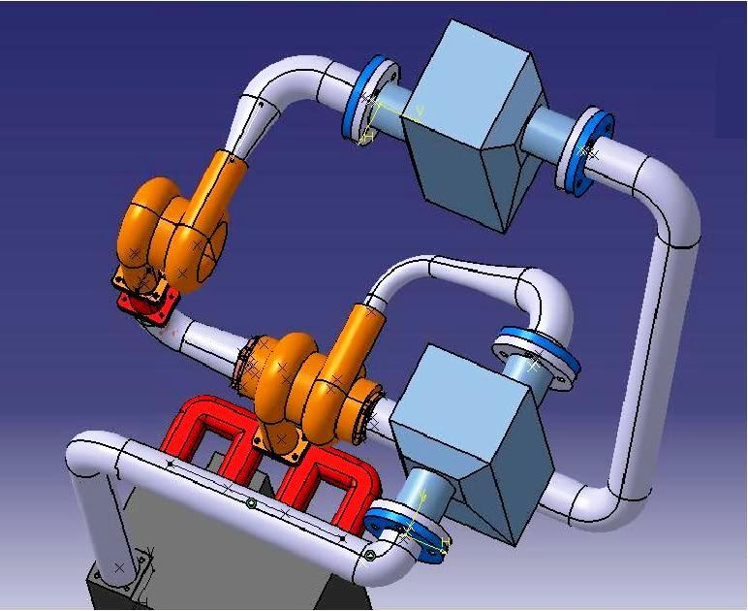

Fig. 1.Layout of Turbochargers and Intercoolers on the engine test bed (schematic).

Engine Specifications:
Make and model: Kirloskar Oil Engines Ltd., 4K1080TA
Power: 156 hp @1500 rpm
Bore X Stroke: 105 X 125 mm
No. of cylinders: 4
AFR: 23:1
Specific fuel consumption: 150 g/hp-hr
Torque: 1331 N-m
Displacement: 4329 CC
Turbocharger Specifications:

LP Make and model = KKK-K27 3371 OLAKE 15 2 1

HP Make and model = KKK-K24 2464 OLAKE 5 1 2

This engine is fitted with two turbochargers in series with an inercooler between the two compressors and an aftercooler between the HP compressor and inlet manifold. This engine needs to be tested first with single stage Turbo Charger and then with two stage Turbo Charger. The test procedure to be followed is as under.
- Remove the second TC and test the engine in regular fashion. The measurement of all the performance parameters during the trials is essential. Increase the load gradually in the steps of 10% and complete the part load. Refer to the attached table.

2. Mount the second TC on the engine and perform the test.

Note: Maintain T3 & T5 equal to 50+/- 5 ⁰ C by adjusting the cooling water flow.
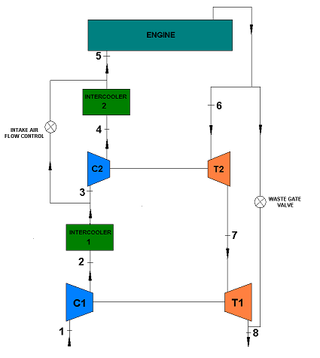
Fig. 2. Selected Layout of HP and LP turbochargers
Turbocharger matching
Let it be numerous advantages a two stage turbo charger offers against single stage, but lot many different complexities are associated with two stage turbo chargers when it comes to its matching. Surprisingly, matching is discussed as a procedure of Trial and Error in most of the studies published on dual stage turbo charger [10, 30] but its also found that the matching should be worked out precisely as it directly affects engine performance. Again a non precise and trial and error nature of matching will surely lead to lower power output at low speeds for partly loaded engines. The principal reason behind this is availability of a very low pressure ratio after every stage in case of a two stage turbo charger when compared to single stage [31].
Benson et al. [32] tried to match a two stage turbo charger by using an externally blown air supply but the engine used by them during this study did not have that much fidelity, leading their studies to limited success.
Today also, two-stage turbocharger used with fixed geometry turbines needs to be improved a lot if used for replacing a heavy volume engine in transient conditions and for low speed conditions.
In his study, Byungchan Lee [33] first chosen a thermodynamic zero dimensional model which was developed by Assanis [34] and then validated the facts laid by Assanis against various engines like Locomotive engines [35]. A Dynamics oriented sub modular system was added to analyse the performance of engine against transient conditions depending upon crank rotations [36]. Lee again added a two stage pressure boosting system to alnalyse the interface of booster and the engine. However Lee has to opt for a simulation oriented proceeding than actual experimentation as the said model was again in need of highly precise matching and tuning.
In this simulation, various models like Air Filter Model, Turbocharger Model, Inlet/Exhaust Manifold Model, In-cylinder Process Model, Valve Flow, Injection Control, and Vehicle System Model were formed and studied. But one has to always keep in mind that the basic flaw associated with a zero-dimensional model that it can not convey or predict the emission oriented end effects and also gas dynamics related issues and hence Cylinder to cylinder alterations can’t be analysed with this engine model. However following important facts should be noted.
1. In this study the convective heat transfer coefficient is calculated from Nusselt-Reynolds correlation for a steady flow through a circular channel which is of turbulent nature following the assumption of Characteristic Flow Velocity [34].
2. The duration of delay period is governed by Mean Cylinder Gas Temperature and pressure and given by an empirical relation by Arrhenius [34].
3. The base for injection control module in this Study depends upon data from M/S International [35] and counts on engine speed, manifold pressure and fuel to be injected with its timing.
In order to match a dual stage turbo charger a systematic approach is to be floated.
The pressure and temperature at the end of first stage is unknown even though overall pressure ratio is known. Therefore it is necessary to assume pressure ratios at the end of each compressor with constant overall pressure ratio. With this we can calculate pressure and temperature at the inlet and exit of the turbochargers and then we can calculate further the pressure ratio and corrected mass flow for turbocharger set. A set of guidelines is roughly suggested by Janota [31] which conveys that dividing the work evenly for each stage keeps the the overall efficiency optimum. But the value of pressure ratio between1.4 to1.7 does not affect the overall efficiency. Hence it is clear that the said guide lines are not adequate to calculate the optimum pressure ratio for every stage.
The basic size of turbocharger was determined by the quantity of air required by the engine. By looking at the basic guide lines presented in the turbocharger manufacturers literature or the complete compressor characteristics curves, a basic frame size of turbocharger may be selected. The final choice of compressor will be made bearing in the mind the complete operating lines of engine over its whole speed and load range, superimposed on compressor characteristics with surge lines in mind. Correction in air filter, intake and exhaust systems were done.

Selection of appropriate pressure ratios for each stage:
TABLE I. SELECTION OF MINIMUM WORK

P2(bar) | W1 (kJ/kg) | W2 (kJ/kg) | W (kJ/kg)
1 | 2.21 | 41.44 | 43.65
1.5 | 11.01 | 28.33 | 39.34
2 | 18.95 | 18.64 | 37.59
2.5 | 25.65 | 11.64 | 37.29⁺
3 | 31.48 | 6.24 | 37.72
3.5 | 36.67 | 1.89 | 38.56

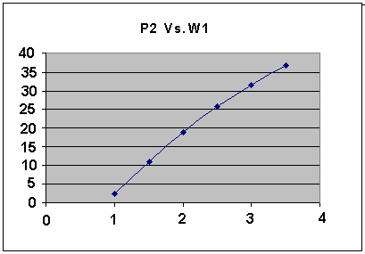
Fig. 3.Graph plot for ${ P}_{2 }$Vs $W_{1}$
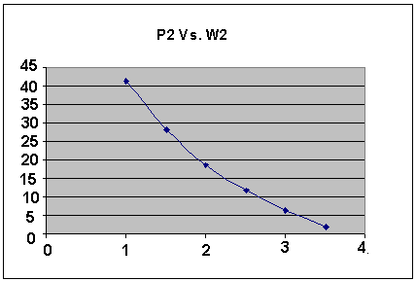
Fig. 4.Graph plot for ${ P}_{2 }$Vs $W_{2}$

Fig. 5 .Graph plot for ${ P}_{2 }$Vs W
It was seen that at P2=2.5 bar, minimum work is required to drive both the HP and LP compressors. Hence, this pressure is selected as the output pressure of LP compressor.
Now the final pressure needed at the inlet manifold i.e. P5=3.7 bar is achieved in the HP stage and the high pressure charge is admitted into the inlet manifold.
Selection of Turbochargers:
Now, for selection of such compressors which would deliver the required pressures, the compressor maps are made available by the turbocharger manufacturers. They are the maps of corrected volume versus the pressure ratio.
So we have to find out the pressure ratios and corrected volumes as per our requirements i.e. as per our calculations. Then we have to plot those lines on compressor maps provided by the turbocharger manufacturers. If our points lie in the highest efficiency zone (centermost region) of the compressor maps, then it implies that the turbocharger is suitable for our application.
Once the basic frame size and compressor have been established, the turbine is matched by altering its volute casing. Thereby, the effective turbine area will change, raising or lowering the energy available at the turbine and hence adjusting the boost pressure from the compressor. These volute casings are available for a particular model of the turbocharger.
The matched compressor maps are given below.
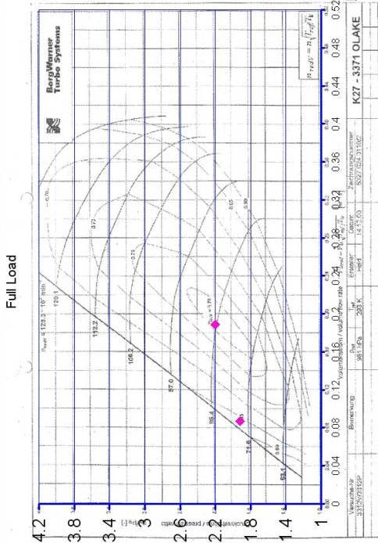

Fig. 6 . Matched LP compressor map
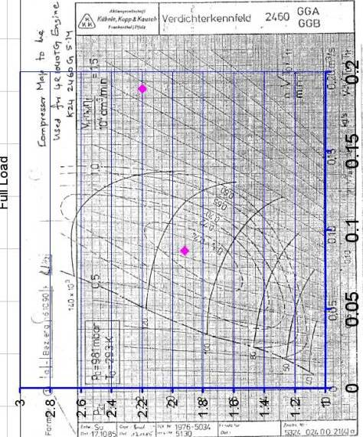

Fig. 7 . Matched H.P compressor map
MATLAB PROGRAM and Regression:
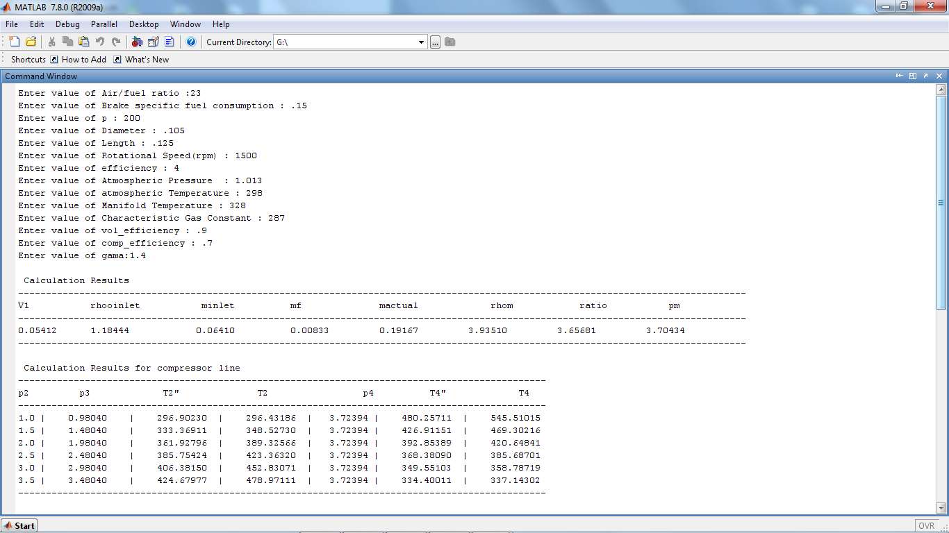
Fig. 7 .OUTPUT generated by MATLAB Code

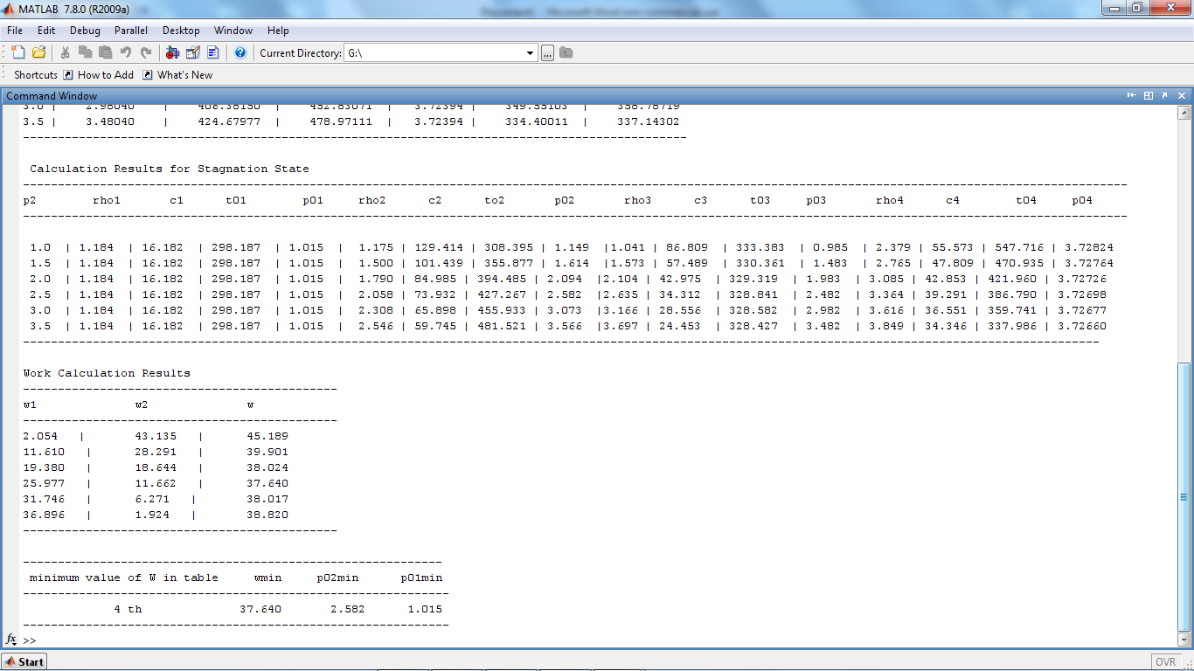
Fig. 8. OUTPUT generated by MATLAB Code
IV. Conclusions
1. The project has dealt with demonstrating the potential of two-stage turbocharging in improving the performance of a turbocharged, 4 stroke diesel engine.
2. The performance parameters predicted by the matching calculations compare well with the experimental results.
3. The intercooler and after cooler surely improved the engine performance and the exhaust temperatures at full load were less than the temperatures with single-stage turbocharging.
4. From the test results it is clear that the volumetric efficiency of the engine has increased as compared to the engine with a single turbocharger.
5. Also, the power output is increased from 156 hp to 200 hp. The testing for full 200 hp power output was not possible on the available test bed, but theoretical analysis suggests that the net power output of 200 hp can be achieved.
6. The mean effective pressure of the engine is increased as is the specific fuel consumption.
7. Considering the thermal stresses on the turbocharger, the maximum temperature at the inlet of the HP turbine was 750⁰C, the power developed at this temperature was 124 hp, at a constant speed of 1500 rpm. So the load corresponding to this power was taken as full load, i.e. 585 Nm.
8. BPR:- Increment in BPR at 50% Load = 9.87%
Increment in BPR at full Load = 6.83%
9. Expansion ratio (Overall):-
Increment at 50% Load = 14.37%
Increment at full Load = 2.4%
10. Temperature before turbine/exhaust manifold: Slight Reduction
11. Specific fuel consumption (gm/hp): Considerable Reduction.

References
- Keppeler, S., Schulte, H., and Hermann Josef Ecker, H. J., “The Technical Ramifications of Downsizing HSDI Diesel Technology to the 300 cc Displacement Class,” SAE paper, 981916.
- Fontanesi, S, Cantore, G., and. Mattarelli, E.,, “A New Concept of Supercharging Applied to High Speed DI Diesel Engines,” SAE paper 2001-01-2485.
- Ecker, H. J., Schwaderlapp, M., and Gill, D. K.,” Downsizing of Diesel Engines: 3- Cylinder / 4-Cylinder,” SAE paper 2000-01-0990.
- Wenger, U, Guzzella, L., and Martin, R., “IC-Engine Downsizing and Pressure-Wave Supercharging for Fuel Economy,” SAE paper 2000-01-1019.
- Atkins, M. J., and Koch, C. R., “A Well-to-Wheel Comparison of Several Powertrain Technologies,” SAE paper 2003-01-0081.
- Lecointe, B., and Monnier, G., “Downsizing a Gasoline Engine Using Turbocharging with Direct Injection,” SAE paper 2003-01-0542.
- Stoffels, H., and Schroeer, M., “NVH Aspects of a Downsized Turbocharged Gasoline Powertrain with Direct Injection,” SAE paper 2003-01-1664.
- Beatrice, C., Belardini P., Bertoli, C., Del Giacomo, N., and Migliaccio, M., “Downsizing of Common Rail D.I. Engines: Influence of Different Injection Strategies on Combustion Evolution,” SAE paper 2003-01-1784.
- Saulnier, S., and Guilain, S., “Computational Study of Diesel Engine Downsizing Using Two-StageTurbocharging,” SAE paper 2004-01-0929.
- Lake, T., Stokes, J., Murphy, R., Osborne, R., Schamel, A., “Turbocharging Concepts for Downsized DI Gasoline Engines,” SAE paper 2004-01-0036.
- Attard, W., Watson, H. C., Konidaris, S., and Khan, M. A., “Comparing the Performance and Limitations of a Downsized Formula SAE Engine in Normally Aspirated, Supercharged and Turbocharged Modes,” SAE paper 2006-32-0072.
- Lefebvre, A., and Guilain, S., “Modelling and Measurement of the Transient Response of a Turbocharged SI Engine,” SAE paper 2005-01-0691.
- Watanabe, T., Koike, T., Furukawa, H., Ikeya, N., Sakakida, M., “Development of Turbocharger for Improving Passenger Car Acceleration,” SAE paper 960018.
- Kawaguchi, J., Adachi, K., Kono, S., and Kawakami, T., “Development of VFT (Variable Flow Turbocharger),” SAE paper 1999-01-1242.
- Kattwinkel, T., Weiss, R., and Boeschlin, J. P., “Mechatronic Solution for Electronic Turbocharger,” SAE paper 2003-01-0712.
- Cantemi, C. G., “Twin Turbo Strategy Operation,” SAE paper 2001-01-0666.
- Okmoto, H., Tashima, S., Fujimoto, Y., and Nakao, M, “ Sequential Twin Turbocharged Rotary Engine of the Latest RX-7,” SAE paper 941030.
- Choi, C., Kwon, S., and Cho, S., “Development of Fuel Consumption of Passenger Diesel Engine with 2 Stage Turbocharger,” SAE paper 2006-01-0021.
- Serrano, J. R., Arnau, F. J., Dolz, V., Tiseira, A., Lejeune, M., and Auffret, N., “Analysis of the Capabilities of a Two-stage Turbocharging System to Fulfill the US2007 Anti-Pollution Directive for Heavy Duty Diesel Engines,” International Journal of Automotive Technology, Vol. 9, No. 3, pp. 277-288 (2008).
- Bonello, M. J., Caldwell, D. M., Pigott, J. A., Prior, G. P., and Schag, T. M., “The Supercharged Northstar DOHC 4.4L V8 Engine for Cadillac,” SAE paper 2005-01- 1854.

